**Lab Hands On Final CLO# 4**

Name ________________________________ Date ______________

1. Band 1 - Orange Resistor Value = ________________

Band 2 - Yellow Tolerance in % = ________________

Band 3 - Red Tolerance in Ohms = _____________

Band 4 - Gold Minimum Resistor Value = _____________

Minimum Resistor Value = _____________

1. Band 1 - Gray Resistor Value = ________________

Band 2 - Blue Tolerance in % = ________________

Band 3 - Red Tolerance in Ohms = _____________

Band 4 - Silver Minimum Resistor Value = _____________

Minimum Resistor Value = _____________

1. Band 1 - Brown Resistor Value = ________________

Band 2 - Black Tolerance in % = ________________

Band 3 - Black Tolerance in Ohms = _____________

Band 4 - None Minimum Resistor Value = _____________

Minimum Resistor Value = _____________

1. Band 1 - Green Resistor Value = ________________

Band 2 - Violet Tolerance in % = ________________

Band 3 - Yellow Tolerance in Ohms = _____________

Band 4 - Gold Maximum Resistor Value = _____________

Minimum Resistor Value = _____________

1. Band 1 - Red Resistor Value = ________________

Band 2 - Yellow Tolerance in % = ________________

Band 3 –Red Tolerance in Ohms = _____________

Band 4 - Gold Minimum Resistor Value = _____________

Maximum Resistor Value = _____________

1. If an additional resistor is added in series, circuit current will:
2. increase
3. decrease
4. no change

From the scope waveform below, determine the following;

|  |  |
| --- | --- |
| Time/cm = 20µS  Volt/cm = 50mV |  |

1. Time _____________
2. Frequency _____________
3. VPP _____________
4. VP _____________
5. VRMS _____________

Settings: Time/cm = 100µSec

|  |  |
| --- | --- |
|  |  |

1. The signal on channel 1 indicates the waveform of?
   1. Circuit current
   2. Circuit voltage
2. The signal on channel 2 indicates the waveform of?
   1. Circuit current
   2. Circuit voltage
3. Determine the following values based upon the scope and circuit information.

Frequency _____________

Phase Angle _____________

Resistor 500Ω

Impedance _____________

Inductive Reactance _____________

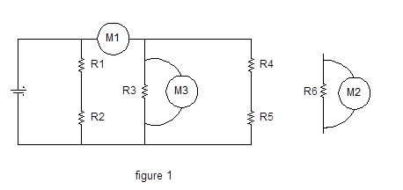

Using figure 1, answer the following.

1. What will meter M1 be measuring? _____________
2. What will meter M2 be measuring? _____________
3. What will meter M3 be measuring? _____________